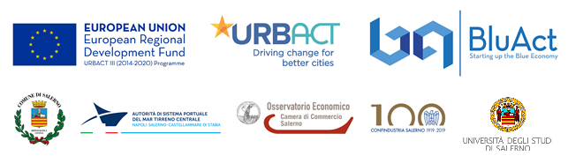

QUESTIONNAIRE

Questionnaire form for the identification of potential stakeholders
of the BLUACT project of the city of Salerno

ATTENTION: Before completing the questionnaire, please, read the informed consent. Thank you.

PERSONAL DATA

Name

Surname

Gender (M / F)

Resident in Salerno (YES/NO)

Age (insert 1 if less than 35 years; 2 between 35 and 65 years; 3 if over 65 years)

Name (for associations, organizations, companies, etc.)

Type (Association, Organization, Company, etc.)

e-mail and/or telephone number

BLUE ECONOMY

1) Do you believe that the Blue Economy has a priority role in the development of the city of Salerno?

A) Priority level (enter 1 if Low; 2 if Medium; 3 if High)

B) Areas of the City of Salerno for which it is deemed a priority to intervene
Express maximum 2 preferences
- Port
- Seafront promenade (“Lungomare”)
- Coast towards Paestum (“Litoranea”)
- Other (indicate name)
1-
2-

C) Interventions deemed most urgent
Express maximum 2 preferences
- Investments in structures
- Infrastructure enhancement
- Support interventions for the creation of new businesses through direct incentives,
service offerings and/or micro-finance interventions
- Support for innovative business activities
1-
2-

Other (if YES, indicate the proposal in the box below)

D) Topics of greater interest
Express maximum 2 preferences
- Marine environment and coastal zone
- Blue biotechnology
- Renewable energy from the sea
- Marine abiotic resources
- Shipbuilding and marine robotics
- Skills & Job
- Research infrastructures
- Sustainability and economic uses of the sea
- Tourism activities
1-
2-

Other (if YES, indicate the proposal in the box below)

2) Development of the cultural and tourist identity of the city

A) Priority level (enter 1 if Low; 2 if Medium; 3 if High)

B) Areas of the City of Salerno for which it is deemed a priority to intervene
Express maximum 2 preferences
- City
- Old town
- Eastern coast (“Litoranea orientale”)
- Neighbourhood (indicate name)
1-
2-

C) Interventions deemed most urgent
Express maximum 2 preferences
- Interventions for the protection and enhancement of cultural heritage and for the
establishment of respective networks
- Support for the integrated use of cultural and natural resources and the promotion
of tourist destinations
1-
2-

Other (if YES, indicate the proposal in the box below)

3) Involvement in the URBACT BLUACT Salerno programme

A) Level of knowledge of the project (insert 1 if Low; 2 if Medium; 3 if High)

B) Level of interest in participating in the implementation of the "Urbact - BluAct Salerno" project (insert 1 if Low; 2 if Medium; 3 if High)

C) What skills and experiences can you bring to the transfer network to share with the partners?
1-
2-

D) With what types of local stakeholders do you already work on these issues and who else would you try to involve? Such as?

PLEASE, SEND TO THE MUNICIPALITY
This form can be:
downloaded from the website www.comune.salerno.it or www.bluactsalerno.unisa.it

The completed form, by 12 noon on 23 December 2019, can be:
1. sent via e-mail to: risorse_comunitarie@comune.salerno.it
2. hand delivered to the Community Resources Service: Servizio Risorse Comunitarie via Portacatena, 42
3. hand delivered on 5 and 6 December 2019 at the Salerno Municipality desk at the Maritime Station.
Thank you for your collaboration.

