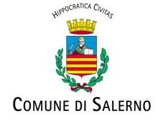
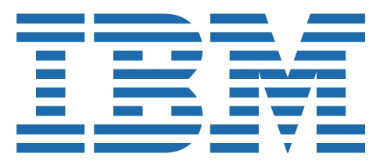

Salerno and IBM
to co-operate to develop a Smarter City

Salerno, Italy, 19 May 2009 - The city of Salerno has entered into a strategic initiative with IBM (NYSE:IBM) with the aim of creating a Smart City. Salerno is the third Italian city to create an Innovation Board with IBM to identify and design a new model for a sustainable city through a range of digital solutions. Last month, IBM and the cities of Parma and Reggio Emilia announced a similar initiative.

Salerno is a modern city in Southern Italy and the city's management is planning citizen-focused innovations to provide new "intelligence" for existing infrastructure to optimize resources, improve new services to citizens and businesses and make the city smarter and more efficient.

Salerno's strategy matches IBM's vision of a Smarter Planet, infusing intelligence into the world's systems, processes and infrastructure and providing a better quality of life for people living and working in a Smarter City. This means a systemic and open approach, with new intelligence through innovative IBM solutions designed with and for Salerno.

The Salerno’s Town Council is focusing on facilitating accessibility to the town and supporting senior citizens through the development of four key initiatives, following the IBM “Human Centric” systemic approach:

The first project is to overcome architectural barriers to create a special route for the blind from a dedicate parking to access their place at the Verdi Theatre. Smart sensors will be placed in the planking and will interact with smart sticks, allowing the visually impaired to receive information and prompts on their mobile phones enabling them to navigate around potential obstacles.

Two dimensional tags will be used to exploit the cultural and artistic heritage and better serve citizens. A smart tourist route will be created within the famous citizen park Il Giardino di Minerva, in the old town of Salerno, providing visitors with information through their mobile phones as they explore the area.

On a longer term, the third solution, called “I am well”, will provide distance health monitoring of the elderly, through a simply electronic device which will advise them on the right time to take medication, monitor their own blood pressure, and provide a doctor and family member with an online updated status report.

The fourth solution will be an ambitious project relating urban mobility. The idea is to build an urban traffic monitoring and control system, using – after due increasing – technological components already available on the territory as traffic lights, limited access streets control cameras, surveillance cameras, etc. The project would allow for the general management of information about mobility, such as parking lots proximity, available slots, timing, tariffs, etc.

“Salerno is proud to agree - says Vincenzo De Luca Mayor of Salerno – to IBM Smarter Town vision. The choice of Parma and Salerno in Italy is a further evidence of Salerno’s excellence and sensitivity to security, urban transformation and solidarity”. “I’m confident that the partnership with IBM – added Mr. De Luca – will allow the promotion of research and the application of technologies to improve our lives thanks to a positive collaboration between Public Administration and private Companies.”

Elsewhere, IBM is working with many other authorities on smarter systems. The cities of Singapore, Brisbane and Stockholm are all working to reduce both congestion and pollution through intelligent transport solutions. These solutions and many more are making a real impact today, the first step towards creating a true smart city.

"It is vital for the future that we transform our cities into accessible, dynamic, thriving communities.” said Luciano Martucci, General Manager IBM Italy. “In cities like Salerno, technology can make the local systems and infrastructure smarter and create benefits directly related toward improving the quality of life for all its citizens, in a cost-effective way".

For information:
http://www.ibm.com/ibm/ideasfromibm/us/smartplanet/20081106/index.shtml?sa_campaign=message/ideas/learnabout/all/smarterplanet

For press:
IBM Italia, Relazioni Esterne: Alessandro Ferrari, + 39 348.4554535, Paola Piacentini + 39 335.1270646
Comune di Salerno, Ufficio Stampa Giuseppe Iannicelli + 39 335.1702128; Daniela Apolito + 39 339.6406469

